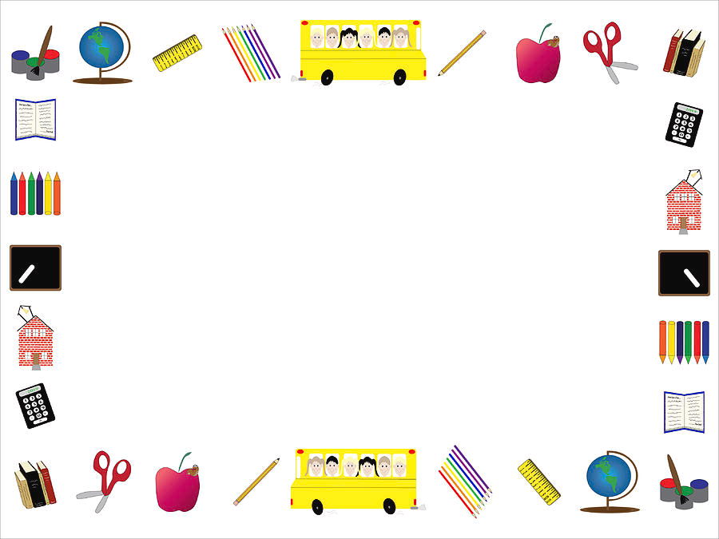

Second Grade Supply List

$20 for field trips and activities
Hand Sanitizer
Kleenex
Head phones NOT ear buds
Black Sharpies
Clorox Wipes

